Objectives:

* Classes and Objects

**There are 6 Challenge Exercises, each worth 16.6%.**

**Project #1 (Single Class)**

In this example, we define a class called Person. **The __init__ method initializes the name and age attributes to default values.** The get_input method prompts the user to enter their name and age from the console and assigns the values to the corresponding attributes. The display method prints the entered name and age to the console.

We create an instance of the Person class and call the get_input method to take input from the user for name and age. Finally, we call the display method to show the entered name and age on the console.

**Project #2 (Two Classes)**

In this example, we define two classes: Student and Course. The student class has attributes name and student_id, and the Course class has attributes course_number and course_name. Each class has get_input() and display() methods.

We create an instance of the Student class, get input for the student's name and ID using the get_input() method, and display the student's information using the display() method.

We also create an instance of the Course class, get input for the course number and name using the get_input() method, and display the course information using the display() method.

**Project #3 (Three Classes) using separate individual classes.**

**Customer Class**

**Order Class**

**Main Class**

**Project #4**

This class is an example of creating objects and using the *self*-keyword to access variables within this class.

**Challenge Exercise #1:** Continuing from project #4, create a third object (Student3) where the user will be able to enter the student’s information.

**#1 Print screen the input/output with the code below here.**

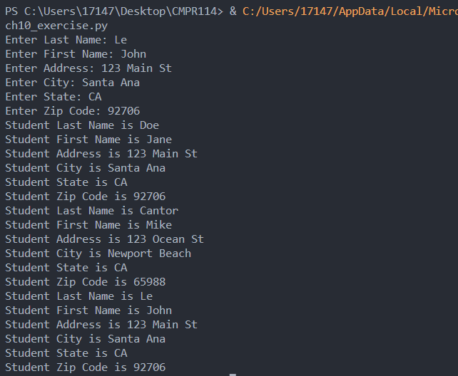

Code:

class Student:

def __init__(self):

self.lastname = ""

self.firstname = ""

self.address = ""

self.city = ""

self.state = ""

self.zipcode = ""

def get_input(self):

self.lastname = input("Enter Last Name: ")

self.firstname = input("Enter First Name: ")

self.address = input("Enter Address: ")

self.city = input("Enter City: ")

self.state= input("Enter State: ")

self.zipcode= input("Enter Zip Code: ")

def GetInformation(self):

print(f"Student Last Name is {self.lastname}")

print(f"Student First Name is {self.firstname}")

print(f"Student Address is {self.address}")

print(f"Student City is {self.city}")

print(f"Student State is {self.state}")

print(f"Student Zip Code is {self.zipcode}")

student1 = Student()

student1.lastname = "Doe"

student1.firstname = "Jane"

student1.address = "123 Main St"

student1.city = "Santa Ana"

student1.state = "CA"

student1.zipcode = "92706"

student2 = Student()

student2.lastname = "Cantor"

student2.firstname = "Mike"

student2.address = "123 Ocean St"

student2.city = "Newport Beach"

student2.state = "CA"

student2.zipcode = "65988"

student3 = Student()

student3.get_input()

student1.GetInformation()

student2.GetInformation()

student3.GetInformation()

**Project #5**

Here we are creating a customized constructor by using the **__init__** function and passing three arguments starting with name, classroom, and then course. This is a lot cleaner than project #1 but function or behaves the same way.

**Challenge Exercise #2:** Add a second object for Teacher 2 and add any teacher name, room #, and course assigned.

**#2 Print screen the input/output with the code below here.**

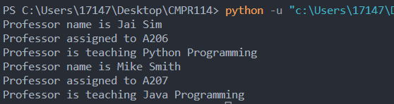

Code:

class Teacher:

def __init__(self, name, classroom, course):

self.name = name

self.classroom = classroom

self.course = course

def GetProfessor(self):

print(f"Professor name is {self.name}")

print(f"Professor assigned to {self.classroom}")

print(f"Professor is teaching {self.course}")

teacher1 = Teacher("Jai Sim", "A206", "Python Programming")

teacher1.GetProfessor()

teacher2 = Teacher("Mike Smith", "A207", "Java Programming")

teacher2.GetProfessor()

**Project #6**

This class is an example of passing parameters and accessing those parameters to get an output.

**Challenge Exercise #3:** for project #6, add the address, city, and state with the zip code.

**#3 Print screen the output with the code below here.**

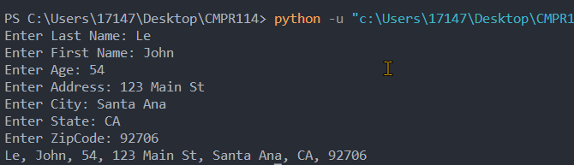

Code:

class PI:

def GetInformation(self, LN, FN, Age, Address, City, State, ZipCode):

return LN + ", " + FN + ", " + Age + ", " + Address + ", " + City + ", " + State + ", " + ZipCode

PIData = PI()

PIData.LastName = input("Enter Last Name: ")

PIData.FirstName = input("Enter First Name: ")

PIData.Age = input("Enter Age: ")

PIData.Address = input("Enter Address: ")

PIData.City = input("Enter City: ")

PIData.State = input("Enter State: ")

PIData.ZipCode = input("Enter ZipCode: ")

print(PIData.GetInformation(PIData.LastName,

PIData.FirstName,

PIData.Age,

PIData.Address,

PIData.City,

PIData.State,

PIData.ZipCode))

**Project #7**

The Customer class creates functions and objects.

**The Second Class**

**Challenge Exercise #4:** for project #7, add the city, and zip code with the person’s age.

**#4 Print screen the output with the code below here.**

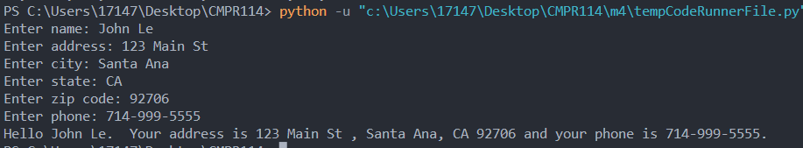

Code:

class Customers:

def __init__(self, name, address, city, state, zipcode, phone):

self.name = name

self.address = address

self.city = city

self.state = state

self.zipcode = zipcode

self.phone= phone

def set_name(self, name):

self.__name = name

def set_address(self, address):

self.__address = address

def set_city(self, city):

self.__city = city

def set_state(self, state):

self.__state = state

def set_zipcode(self, zipcode):

self.__zipcode = zipcode

def set_phone(self, phone):

self.__phone = phone

import Customers

def main():

name = input("Enter name: ")

address = input("Enter address: ")

city = input("Enter city: ")

state = input("Enter state: ")

zipcode = input("Enter zip code: ")

phone = input("Enter phone: ")

var1 = Customers.Customers.set_name = name

var2 = Customers.Customers.set_address = address

var3 = Customers.Customers.set_city = city

var4 = Customers.Customers.set_state = state

var5 = Customers.Customers.set_zipcode = zipcode

var6 = Customers.Customers.set_phone = phone

print(f"Hello {var1}. Your address is {var2} , {var3}, {var4} {var5} and your phone is {var6}.")

main()

**Project #8**

**First Class:** Here we have a class named BankAccount which will be called from another class or an external class. The __init__ allows us to create a custom constructor.

**Second Class**

**#5 Print screen the input/output with the code below here.**

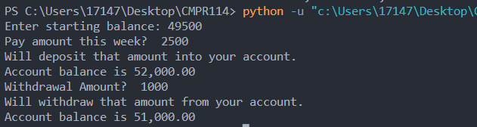

Code:

class BankAccount:

def __init__ (self, balance):

self.__balance = balance

def deposit(self, amount):

self.__balance+=amount

def withdraw(self, amount):

if self.__balance >= amount:

self.__balance-=amount

else:

print("Insufficient funds.")

def get_balance(self):

return self.__balance

import BankAccounts

def main():

start_bal = float(input("Enter starting balance: "))

#Initialize class BankAccount

savings = BankAccounts.BankAccount(start_bal)

pay = float(input("Pay amount this week? "))

print("Will deposit that amount into your account.")

#add to account based upon pay

savings.deposit(pay)

print(f"Account balance is {savings.get_balance():,.2f}")

cash = float(input("Withdrawal Amount? "))

print("Will withdraw that amount from your account.")

savings.withdraw(cash)

print(f"Account balance is {savings.get_balance():,.2f}")

main()

**Challenge Exercise: Complete the following Patient Charges Application below.**

**#6 Print screen the input/output with the code below here. (Need print screen of the code for all classes).**

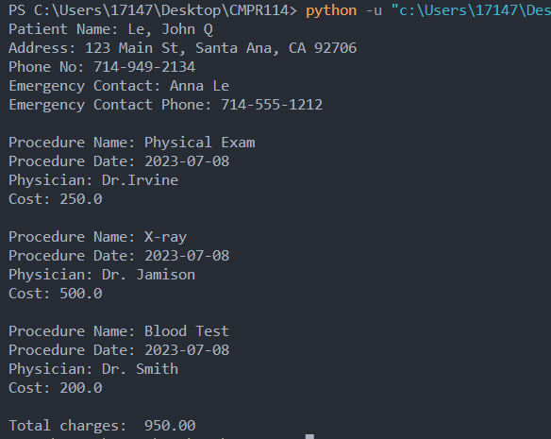

Code:

class Patient:

def __init__(self, firstname, middlename, lastname, address, city, state, zipcode, phone, emergency_contact, emergency_phone):

self.firstname = firstname

self.middlename = middlename

self.lastname = lastname

self.address = address

self.city = city

self.state = state

self.zipcode = zipcode

self.phone = phone

self.emergency_contact = emergency_contact

self.emergency_phone = emergency_phone

def get_firstname(self):

return self.firstname

def get_middlename(self, value):

return self.middlename

def get_lastname(self, value):

return self.lastname

def get_address(self, value):

return self.address

def get_city(self, value):

return self.city

def get_state(self, value):

return self.state

def get_zipcode(self, value):

return self.zipcode

def get_phone(self, value):

return self.phone

def get_emergency_contact(self, value):

return self.emergency_contact

def get_emergency_phone(self, value):

return self.emergency_phone

def get_patient_info(self):

msg = f"Patient Name: {self.lastname}, {self.firstname} {self.middlename}\n"

msg = msg + f"Address: {self.address}, {self.city}, {self.state} {self.zipcode}\n"

msg = msg + f"Phone No: {self.phone}\n"

msg = msg + f"Emergency Contact: {self.emergency_contact}\n"

msg = msg + f"Emergency Contact Phone: {self.emergency_phone}\n"

return msg

def set_firstname(self, value):

self.firstname = value

def set_middlename(self, value):

self.middlename = value

def set_lastname(self, value):

self.lastname = value

def set_address(self, value):

self.address = value

def set_city(self, value):

self.city = value

def set_state(self, value):

self.state = value

def set_zipcode(self, value):

self.zipcode = value

def set_phone(self, value):

self.phone = value

def set_emergency_contact(self, value):

self.emergency_contact = value

def set_emergency_phone(self, value):

self.emergency_phone = value

import Patients

import datetime as datetime

class Procedure:

def __init__(self, procname, procdate, doctor, charges):

self.procedurename = procname

self.proceduredate = procdate

self.doctor = doctor

self.charges = charges

#Assessor attributes

def get_procedurename(self):

return self.procedurename

def get_proceduredate(self):

return self.proceduredate

def get_doctor(self):

return self.doctor

def get_charges(self):

return self.charges

def get_procedure_info(self):

msg = f"Procedure Name: {self.procedurename}\n"

msg = msg + f"Procedure Date: {self.proceduredate}\n"

msg = msg + f"Physician: {self.doctor}\n"

msg = msg + f"Cost: {self.charges}\n"

return msg

def set_procedurename(self, value):

self.procedurename = value

#Mutator attributes

def set_proceduredate(self, value):

self.proceduredate = value

def set_doctor(self, value):

self.doctor = value

def set_charge(self, value):

self.charges = value

patient1 = Patients.Patient("John", "Q", "Le", "123 Main St", "Santa Ana", "CA", "92706", "714-949-2134", "Anna Le", "714-555-1212")

proc1 = Procedure("Physical Exam", datetime.date.today(), "Dr.Irvine", 250.00)

proc2 = Procedure("X-ray", datetime.date.today(), "Dr. Jamison", 500.00)

proc3 = Procedure("Blood Test", datetime.date.today(), "Dr. Smith", 200.00)

#Print Patient Info

print(patient1.get_patient_info())

#Print Procedure

print(proc1.get_procedure_info())

print(proc2.get_procedure_info())

print(proc3.get_procedure_info())

totalcharges = proc1.get_charges() + proc2.get_charges() + proc3.get_charges()

print(f"Total charges: {totalcharges:,.2f}")

**Submit this document to the Module 4 Class Exercise.**